**Final Project**

**Team Members**

|  |  |  |  |
| --- | --- | --- | --- |
| **Full Name** | **Sec.** | **BN** | **Role in the project** |
| Adel Mohamed Abd-Elhmid Rizq | 1 | 33 | Task1 |
| Ahmed Ashraf Hamdy Ahmed | 1 | 2 | Task2 |
| Abdullah Ahmed Hemdan Ahmed | 2 | 1 | Task3 (Encoder a-b-f) |
| Ahmed Mohamed Mohamed Mahmoud Mahboub | 1 | 7 | Task3 (Decoder d-e-c) |

Table of contents:

Project Tasks: 3

Task One: Echo generation and removal 3

Task Two: Audio steganography 4

Task Three: Image compression 5

Appendices 10

Appendix A: Codes for Task One: 10

Appendix B: Codes for Task Two: 12

Appendix C: Codes for Task Three: 13

References: 17

**List of Figures**

Figure 1: Impulse reaponse 3

Figure 2: Magnitude spectrum 4

Figure 3: Original image 6

Figure 4: Red component for original image 6

Figure 5: Green component for original image 7

Figure 6: Blue component for original image 7

Figure 7: Decopressed image with m = 1 8

Figure 8: Decopressed image with m = 2 8

Figure 9: Decopressed image with m = 3 9

Figure 10: Decopressed image with m=4 9

# Project Tasks:

## Task One: Echo generation and removal

All the required results and answers to questions.

All the required figures.

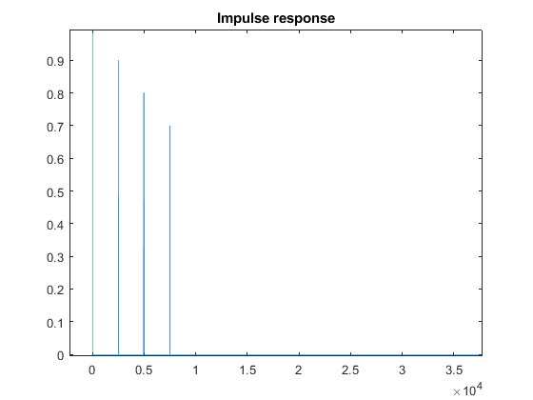

Figure 1: Impulse response

## 

## Task Two: Audio steganography

All the required figures.

* The magnitude Spectrum of X[n]

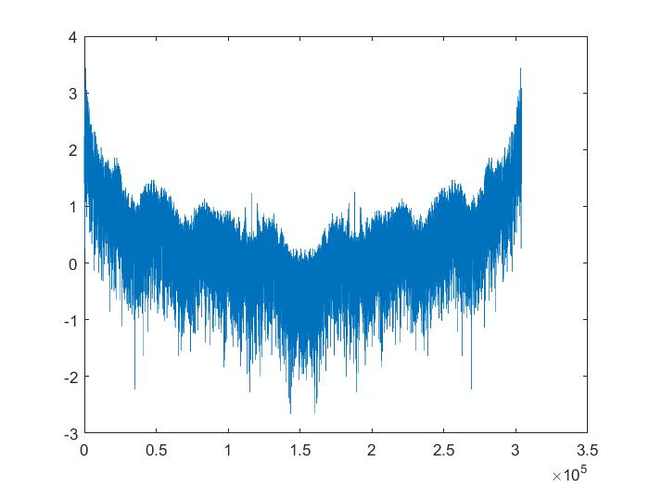

Figure 2: magnitude Spectrum of X[n]

## 

## Task Three: Image compression

C)

Original image size = 6,220,928 bytes

|  |  |
| --- | --- |
| **M** | **size** |
| 1 | 194,528 bytes |
| 2 | 777,728 bytes |
| 3 | 1,749,728 bytes |
| 4 | 3,110,528 bytes |

.

E)

|  |  |
| --- | --- |
| **M** | **PSNR** |
| 1 | 31.515999113230823 |
| 2 | 32.096097015340824 |
| 3 | 32.59529600923095 |
| 4 | 33.25038629758039 |

F) **1.** The main advantage of DCT over DFT is that DCT has a very high degree of spectral compaction at the qualitative level.

**2.** DCT signal’s representation intends to have most of its energy concentrated in a very small number of coefficients for natural photographic images so that the other coefficients having a small amplitude may be discarded easily when compared to DFT.

**3.** In addition to that DCT calculations are much faster than DFT since complicated and complex calculations are avoided.

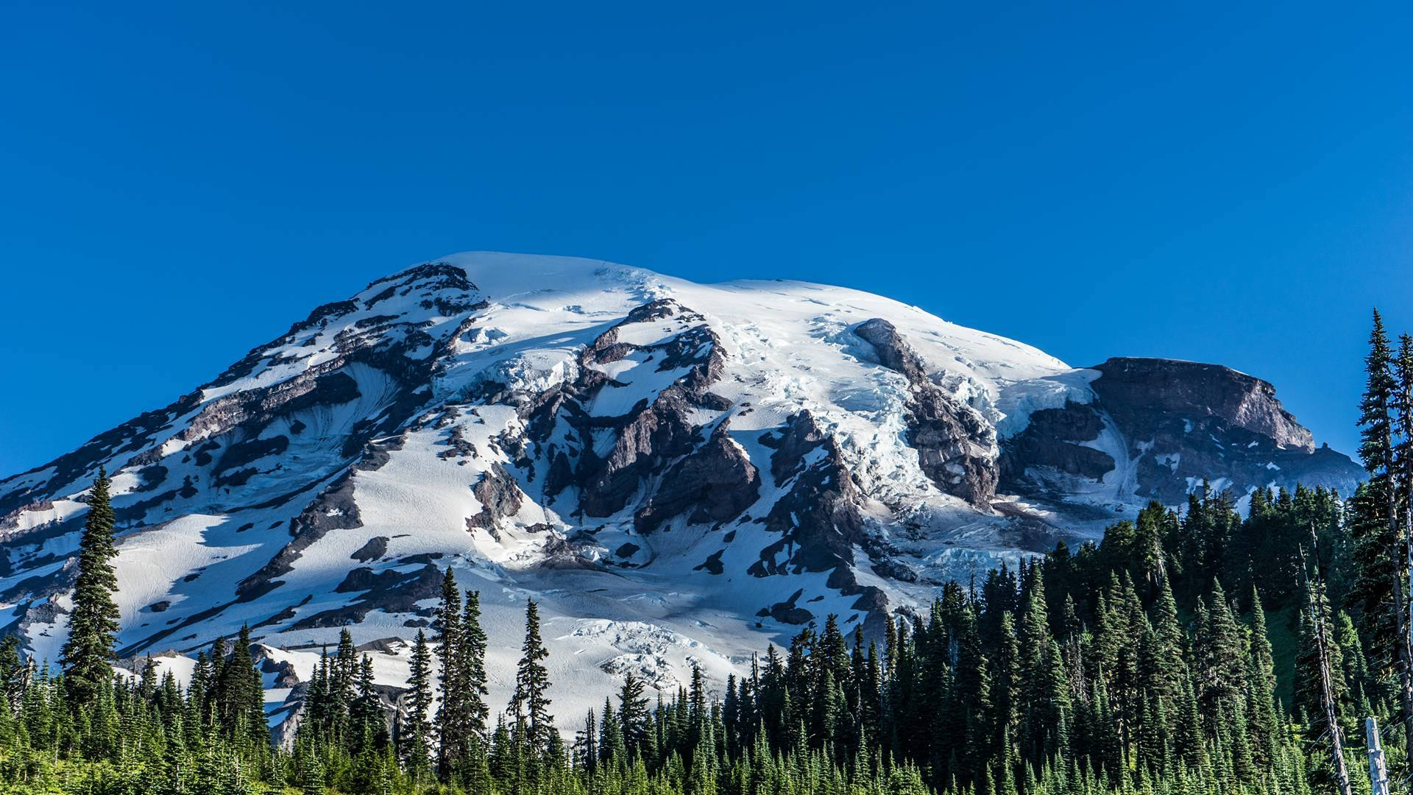

**Figure3: Original image**

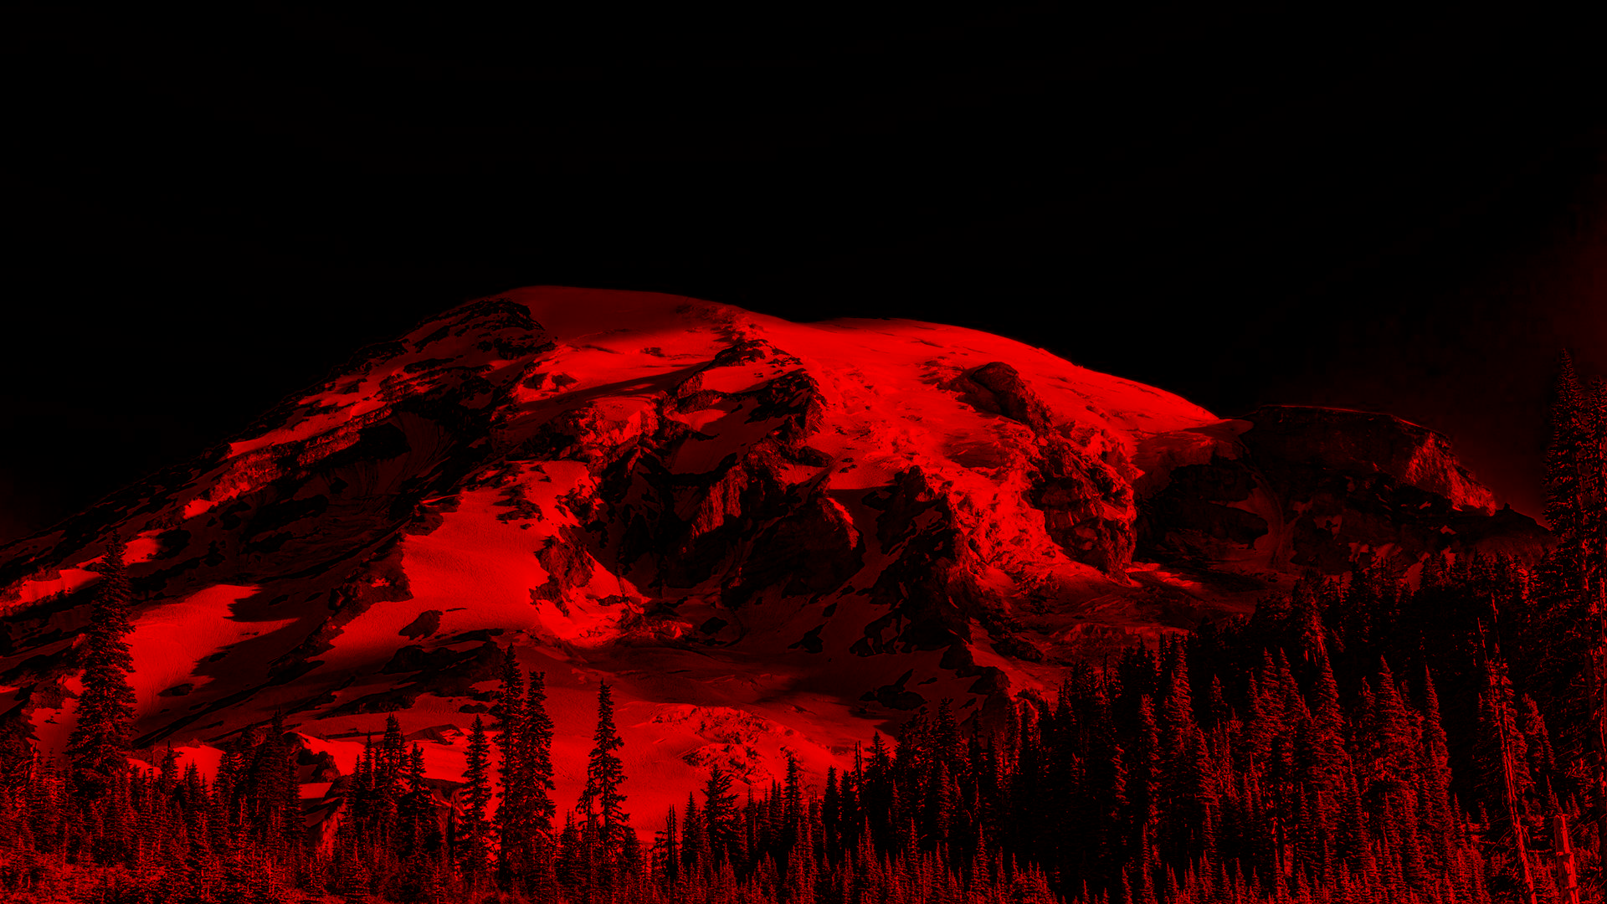

**Figure 4: red component for original image**

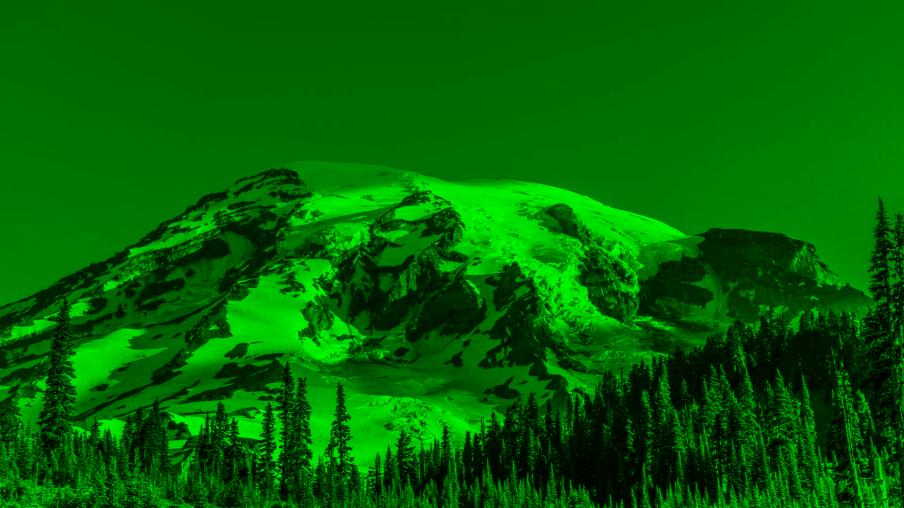

**Figure5: green component for original image**

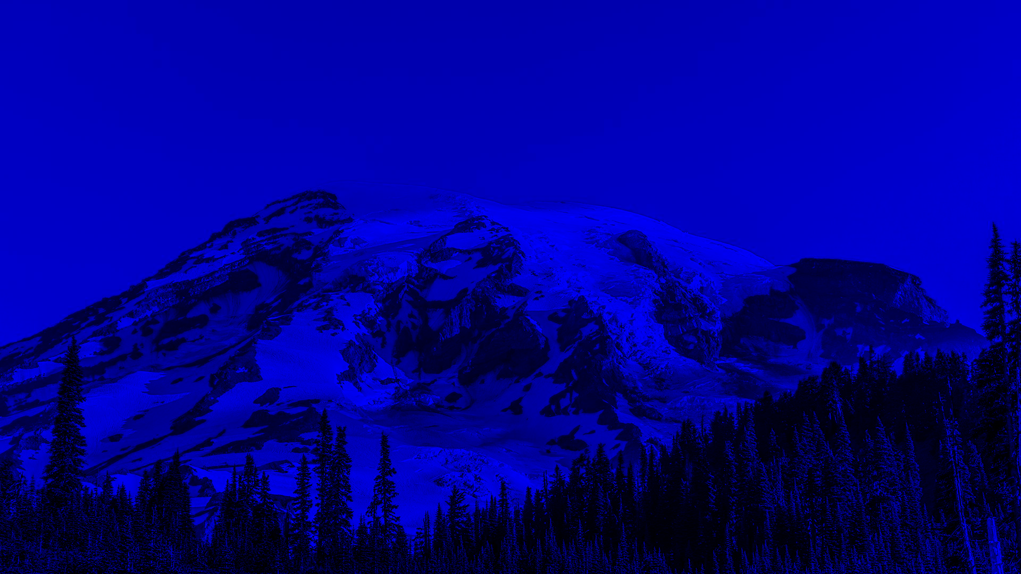

**Figure6: blue component for original image**

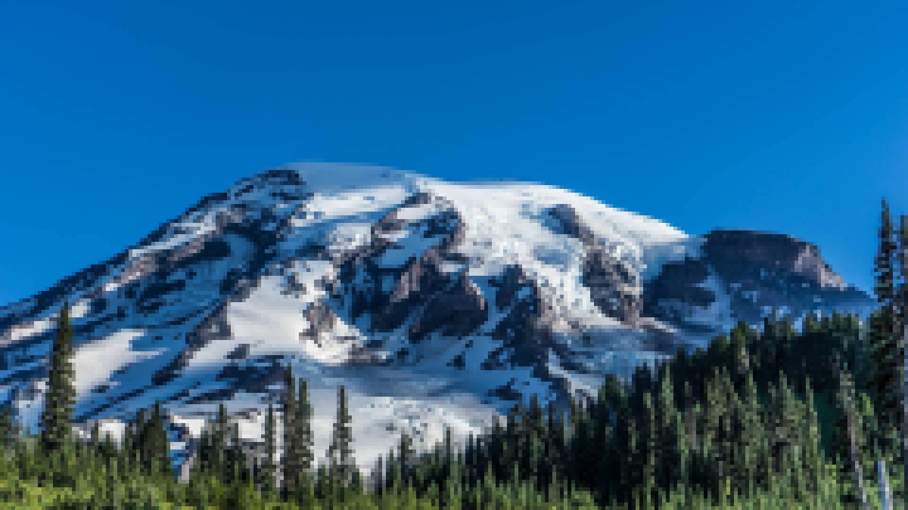

**Figure7: Decompressed Image with m =1**

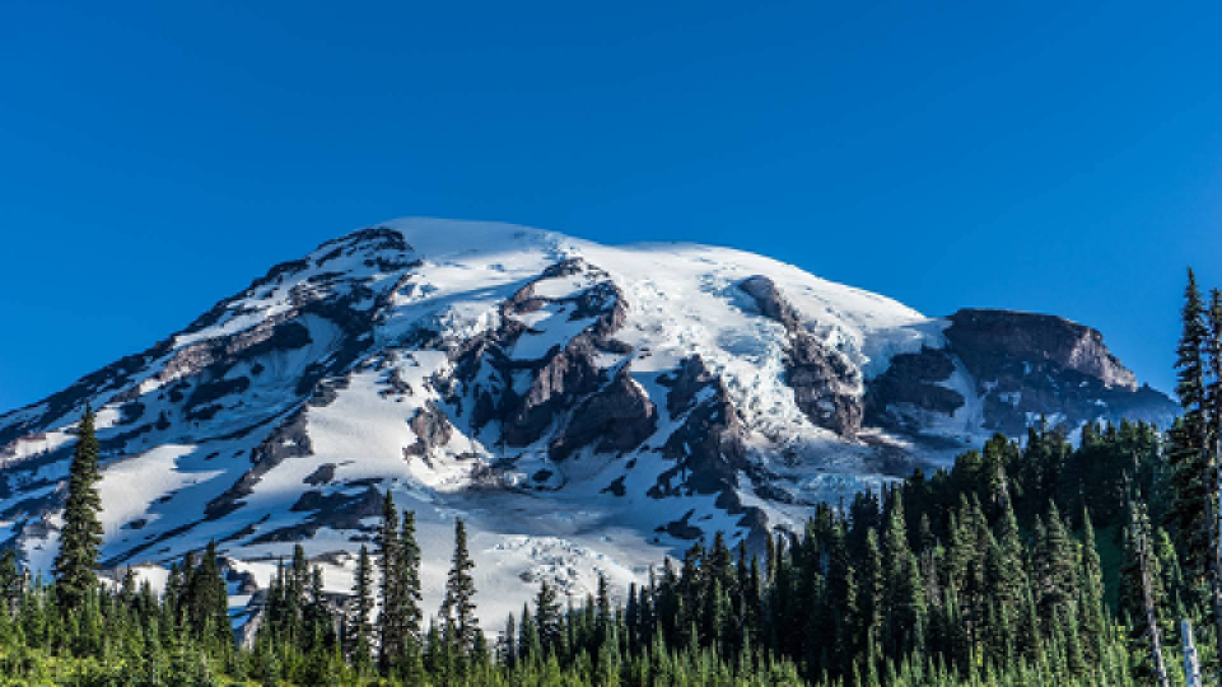

**Figure8: Decompressed Image with m =2**

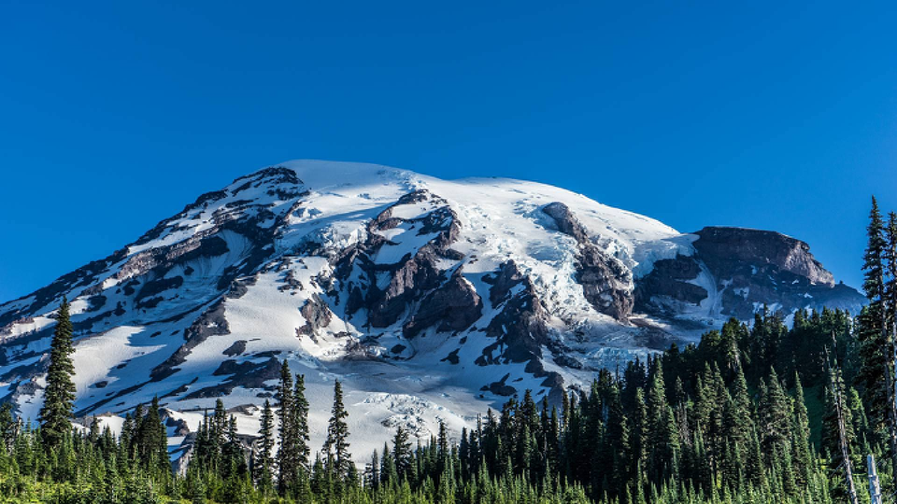

**Figure9r: Decompressed Image with m =3**

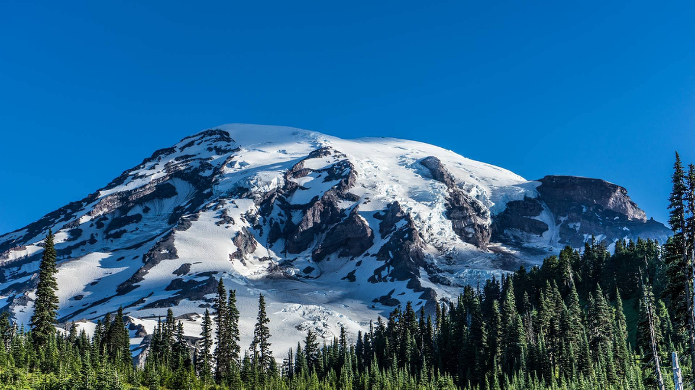

**Figure10: Decompressed Image with m =4**

# 

# Appendices

## Appendix B: Codes for Task One: [Code Link](https://www.ideone.com/OqUl1V)

**%% Read the Audio**

**[x, fs] = audioread("audio1.wav");**

**%% Get y in time domain and add the Echo**

**y_t = zeros(length(x), 1);**

**for i = 1:length(x)**

**y_t(i) = x(i);**

**if i >= 2501**

**y_t(i) = y_t(i) + x(i - 2500) * .9;**

**end**

**if i >= 4991**

**y_t(i) = y_t(i) + x(i - 4990) * .8;**

**end**

**if i >= 7486**

**y_t(i) = y_t(i) + x(i - 7485) * .7;**

**end**

**end**

**sound(y_t); % the audio with echo**

**%% Get the impulse response**

**imp = zeros(length(x), 1);**

**imp(1) = 1;**

**h = imp;**

**for i = 1 : length(h)**

**h(i, 1) = imp(i, 1);**

**if i >= 2501**

**h(i) = h(i) + imp(i - 2500) * .9;**

**end**

**if i >= 4991**

**h(i) = h(i) + imp(i - 4990) * .8;**

**end**

**if i >= 7486**

**h(i) = h(i) + imp(i - 7485) * .7;**

**end**

**end**

**plot(h);**

**title('Impulse response');**

**%% Get y using convolution**

**y = conv(x, h);**

**%% Remove the echo using DFT**

**Y = fft(y);**

**H = fft(h);**

**H = imresize(H, [length(Y), 1]);**

**X = Y ./ H;**

**original_x = real(ifft(X));**

**sound(original_x(1: length(original_x) / 2));**

## Appendix B: Codes for Task Two:



## 

## Appendix C: Codes for Task Three:

This code is written in python:

Packages needed:

* Math
* SciPy
* Cv2
* NumPy

from scipy.fft import dct ,idct  
from math import log10  
import numpy as np  
import cv2  
  
  
# Steps to follow  
  
# 1. Encoder  
# 1.1 Read the image file ‘image1.bmp’. => Done  
# 1.2 Extract and display each of its three color components. => Done  
# 1.3 Convert range of each component to [-128, 127] => Done  
# 1.4 Form a matrix for the outImage with the new size => Done  
# 1.5 Process each color component in blocks of 8×8 pixels. => Done  
# 1.6 Obtain 2D DCT of each block. => Done  
# 1.7 Retain only the top left square of the 2D DCT coefficients of size 𝑚 × 𝑚, The rest of coefficients are ignored. => Done  
# 1.8 Compare the size of the original and compressed images. => Done  
  
# 2. Decoder  
# 2.1 load the out-image=>Done  
# 2.2 display the compressed image=>Done  
# 2.3 Form a matrix for the deCompressed image with the original size => Done  
# 2.4 Get each block of to be decompressed.=>Done  
# 2.5 apply inverse dct on each block=>Done  
# 2.6 re-range the out image by adding 128 ranges from [0 : 255] => Done  
# 2.7 display the decompressed image and Compare them => Done  
# 2.8 quality of the decompressed image is measured using the Peak Signal-to-Noise Ratio PSNR) implementation => Done  
# 2.9 display PSNR for each m => Done  
# 2.9 technical report (advantages of using DCT instead of DFT)  
  
  
# Step 1.3  
def reRange(inputImage):  
 print("inputImage before", inputImage)  
 inputImage = inputImage.astype('int')  
 inputImage -= 128  
 print("inputImage after", inputImage)  
 return inputImage  
  
# Step 1.2  
def getComponent(inputImage, no):  
 # 1. no = 0 => red  
 # 2. no = 1 => green  
 # 3. no = 2 => blue  
 cpy = inputImage.copy()  
 for i in range(3):  
 if(i != no): # not need => Just make it zeros  
 cpy[:, :, i] = 0  
 return cpy  
  
  
  
def imageCompression(inputImage, m, row, col):  
 # Step 1.4  
 outImage = np.zeros(  
 (int((row / 8) * m), int((col / 8) * m), 3), dtype=np.float16)  
  
 blockRow = int(row / 8)  
 blockCol = int(col / 8)  
 blockComponents = 3  
 noIterations = 0  
  
 # Step 1.5  
 for x in range(0, blockRow):  
 for y in range(0, blockCol):  
 for z in range(0, blockComponents):  
 noIterations += 1  
 currentBlock = inputImage[x *  
 8: x * 8 + 8, y * 8: y * 8 + 8, z]  
 # Step 1.6, 1.7  
 blockDCT = dct(dct(currentBlock.T, norm='ortho').T, norm='ortho')[0:m, 0:m]  
 outImage[x * m: x * m + m, y * m: y * m + m, z] = blockDCT  
 print("no Iterations", noIterations)  
 print("outImage", outImage)  
 return outImage  
  
  
# implement 2D IDCT  
def idct2(a):  
 return idct(idct(a.T, norm='ortho').T, norm='ortho')  
# step 2.6  
def deReRange(deCopressedImage):  
  
 deCopressedImage += 128  
 deCopressedImage = deCopressedImage.astype('int')  
 return deCopressedImage  
  
  
def imageDeCompression(toBeCompressedImage ,m , row ,col):  
 # Step 2.3  
 deCompressedImage = np.zeros((int((row / m) * 8), int((col / m) * 8), 3), dtype=np.float16)  
  
 blockRow = int(row / m)  
 blockCol = int(col / m)  
 blockComponents = 3  
 noIterations = 0  
  
 # Step 2.4  
 for x in range(0, blockRow):  
 for y in range(0, blockCol):  
 for z in range(0, blockComponents):  
  
 noIterations += 1  
 currentBlock = toBeCompressedImage[x * m: x * m + m, y * m: y * m + m, z]  
 deCompressedBlock = np.zeros((int(8), int(8)), dtype=np.float16)  
 deCompressedBlock[0: m, 0: m] = currentBlock  
  
 # Step 2.5  
 blockIDCT = idct2(deCompressedBlock)  
 deCompressedImage[x*8:x*8+8, y*8:y*8+8, z] = blockIDCT  
  
 # Step 2.6  
 deCompressedImage =deReRange(deCompressedImage)  
 return deCompressedImage  
  
  
# Step 2.8  
def getPSNR(original, compressed):  
  
 MSE = np.mean((original - compressed) ** 2)  
 max_pixel = 255.0  
 PSNR = 10 * log10((max_pixel*max_pixel) / MSE)  
 return PSNR  
  
  
# Step 1.1  
inputImage = cv2.imread('./image1.bmp')  
np.save("inputImage", inputImage)  
  
row = inputImage.shape[0]  
col = inputImage.shape[1]  
m = int(input('Enter the value of m between [1 - 4] : '))  
  
cv2.imshow("Input Image", inputImage)  
cv2.waitKey(0)  
cv2.destroyAllWindows()  
  
  
# Step 1.2  
# Get Red Component  
redComponent = getComponent(inputImage, 2)  
cv2.imwrite("redComponent.bmp", redComponent)  
cv2.imshow("Red Component", redComponent)  
cv2.waitKey(0)  
cv2.destroyAllWindows()  
  
# Get Green Component  
greenComponent = getComponent(inputImage, 1)  
cv2.imwrite("greenComponent.bmp", greenComponent)  
cv2.imshow("Green Component", greenComponent)  
cv2.waitKey(0)  
cv2.destroyAllWindows()  
  
  
  
# Get Blue Component  
blueComponent = getComponent(inputImage, 0)  
cv2.imwrite("blueComponent.bmp", blueComponent)  
cv2.imshow("Blue Component", blueComponent)  
cv2.waitKey(0)  
cv2.destroyAllWindows()  
  
# Step 1.3  
inputImage = reRange(inputImage)  
  
# Step 1.8  
outImage = imageCompression(inputImage, m, row, col)  
print("Output Image", outImage)  
np.save("outImage", outImage)  
  
# Step 2.1  
toBeCompressedImage = np.load("outImage.npy")  
  
# Step 2.2  
print("decompressed", toBeCompressedImage)  
deRow = toBeCompressedImage.shape[0]  
deCol = toBeCompressedImage.shape[1]  
  
deCompressedImage = imageDeCompression(toBeCompressedImage, m, deRow, deCol)  
print("deCompressedImage", deCompressedImage)  
print("inputImage", inputImage)  
print(deCompressedImage.shape[0], deCompressedImage.shape[1])  
  
# Step 2.7  
cv2.imwrite("deCompressedImage.bmp", deCompressedImage)  
deCompressedImage = cv2.imread("./deCompressedImage.bmp")  
cv2.imshow("deCompressed Image", deCompressedImage)  
cv2.waitKey(0)  
cv2.destroyAllWindows()  
  
# Step 2.9  
inputImage = cv2.imread('./image1.bmp')  
deCompressedImage = cv2.imread("./deCompressedImage.bmp")  
PSNR = getPSNR(inputImage, deCompressedImage)  
print("PSNR", PSNR)

# References:

1. References for question (**F)** What are the advantages of using DCT instead of DFT for compression.
   * 1. The Discrete Cosine Transform(DCT) Theory and Application Research  
        prepared by Syed Ali Khayam from Department of Electrical & Computer Engineering

Michigan State University [Research download link](https://www.researchgate.net/deref/http%3A%2F%2Fciteseerx.ist.psu.edu%2Fviewdoc%2Fdownload%3Fdoi%3D10.1.1.184.6102%26rep%3Drep1%26type%3Dpdf).

* + 1. Answer of question “what is the difference between DCT and DFT” from Research Gate website [Answer Link](https://www.researchgate.net/post/What_does_Discrete_Cosine_Transform_DCT_do).
    2. Answer from Quora about “why DCT preferred over DFT” [Answer Link](https://www.quora.com/Why-is-DCT-preferred-for-image-processing).
    3. Answer from Stack Exchange website [Answer Link](https://dsp.stackexchange.com/questions/13/what-is-the-difference-between-a-fourier-transform-and-a-cosine-transform).